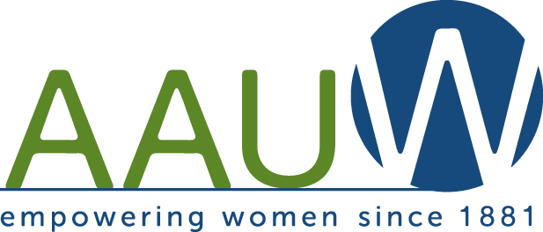 Northern Ocean County Branch
$1,000 Academic Scholarship Announcement
The American Association of University Women Northern Ocean County Branch (AAUW-NOCB) will award a $1,000 academic scholarship.
Qualifications:
- Reentering adult female
- 21 years of age or older
- Resident of Ocean or Monmouth County, NJ
- Continuing undergraduate education
- Completed at least 12 college credits towards a Bachelor’s Degree
- Will be enrolled in school year 2018-2019

Interested women may complete the requirements and mail them to:
AAUW-NOCB
2003 Edwards Layne
Toms River, NJ 08753

Please include your name, address, e-mail address and telephone number.

Applications must be completed and returned to the address above by May 10, 2018.

If you have any questions contact us at AAUWNOCBNJ@gmail.com.
Please include in the subject area “Academic Scholarship”.

Northern Ocean County Branch
$1,000 Academic Scholarship Application
Name: Phone number:
Address:

Email address:
Which college have you attended, and how many credits have you earned?

Which college do you plan to attend in September 2018?

Awards, Honors, and Scholarships

Community Service

Membership in Clubs and Organizations
Name of Club or Organization Office held

Interests and Hobbies

Requirements:
- Letter of college acceptance. Send a copy of your college acceptance
- Proof of Registration: Include or arrange to have an official copy of your first semester classes mailed.
- Application: Complete AAUW NOCB application.
- College Transcript: Include or arrange to have an official transcript from prior college studies mailed.
- Essay: On a separate sheet, in not more than two double-spaced pages, discuss your reasons for returning to higher education. Please discuss your educational and career goals and personal ambitions.
- Envelope size: Please mail in a #10 envelope (4 1/8 inches by 9 1/2 inches).
- Applications must be completed and returned by May 10, 2018 to:
AAUW-NOCB
2003 Edwards Layne
Toms River, NJ 08753

Certification: I certify that this information is true, complete and accurate. I authorize release for the appropriate usage and public acknowledgement of the scholarship.

Applicant Signature Date

