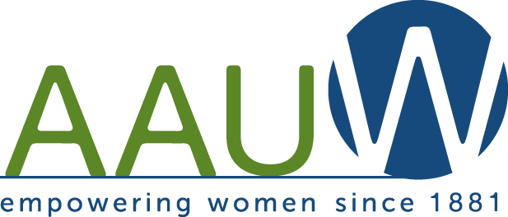
Northern Ocean County Branch
$2,000 Reentering Scholarship Announcement
The American Association of University Women Northern Ocean County Branch (AAUW-NOCB) will award a $2,000 scholarship.
Qualifications:
- Reentering adult female
- 21 years of age or older
- Resident of Ocean or Monmouth County, NJ
- Continuing undergraduate education
- Completed at least 12 college credits towards a Bachelor’s Degree
- Will be enrolled in school year 2020-2021
- Embrace the mission of AAUW: The American Association of University Women (AAUW) advances equity for women and girls through advocacy, philanthropy, and research.

Interested women may complete the requirements and mail them to:

AAUW-NOCB
207 Chatham Lane
Pt. Pleasant, NJ 08742

Please include your name, address, e-mail address and telephone number.

Applications must be completed and returned to the address above by May 11, 2020.

If you have any questions contact us at AAUWNOCBNJ@gmail.com.
Please include in the subject area “AAUW-NOCB Reentering Scholarship”.
Northern Ocean County Branch
$2,000 Reentering Scholarship Application
Name: Phone number:
Address:

Email address:
Which college have you attended and how many credits have you earned?

Which college do you plan to attend in September 2020?

Awards, Honors, and Scholarships

Community Service

Membership in Clubs and Organizations
Name of Club or Organization Office held

Interests and Hobbies

Requirements:
- Letter of college acceptance. Send a copy of your college acceptance,
- Proof of Registration: Include or arrange to have an official copy of your first semester classes mailed.
- Application: Complete AAUW NOCB application.
- College Transcript: Include or arrange to have an official transcript from prior college studies mailed.
- Essay: On a separate sheet, in not more than two double-spaced pages, discuss your reasons for returning to higher education. Please discuss your educational and career goals and personal ambitions and how you embrace the mission of AAUW. Explain why you should be awarded this scholarship.
- Envelope size: Please mail in a #10 envelope (4 1/8 inches by 9 1/2 inches).
- Applications must be completed and returned by May 11, 2020 to:

AAUW-NOCB
207 Chatham Lane
Pt. Pleasant, NJ 08742

Certification: I certify that this information is true, complete and accurate. I authorize release for the appropriate usage and public acknowledgement of the scholarship.

Applicant Signature Date

