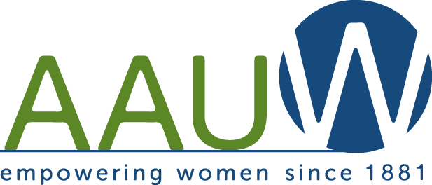
Northern Ocean County Branch
(AAUW-NOCB)
Kathleen Barra Memorial $1,000 Scholarship Announcement
The American Association of University Women Northern Ocean County Branch (AAUW) will award a $1,000 scholarship in memory of one of our members, Kathleen Barra.
Qualifications:
- High school senior, class of 2023
- Resident of Ocean or Monmouth County, NJ
- Enrolled full time in college in the school year 2023 - 2024
- Major in business related program
- Embrace the mission of AAUW: The American Association of University Women (AAUW) advances equity for women and girls through advocacy, philanthropy, and research.

Interested women may complete the requirements and mail them to:

AAUW-NOCB
207 Chatham Lane
Pt. Pleasant, NJ 08742

Applications must be completed and returned by May 1, 2023.

If you have any questions, please contact us at AAUWNOCBNJ@gmail.com.
Please include in the subject area “Kathleen Barra Memorial Scholarship”.

Northern Ocean County Branch
Kathleen Barra Memorial $1,000 Scholarship Application
Name: Phone number:
Address:

Email address:
Will you graduate from high school in June 2023?
If so, which high school?
Which college do you plan to attend in September 2023?

What business related field do you plan to pursue?
Awards, Honors, and Scholarships

Community Service

Membership in Clubs and Organizations
Name of Club or Organization Office held, if any

Interests and Hobbies

Requirements:
- High School Transcript: Include or arrange to have an official copy of your high school transcript sent
to : AAUW-NOCB, 207 Chatham Lane Pt. Pleasant, NJ 08742.

- Letter of College Acceptance: Send a copy of your college acceptance.

- Essay: On a separate sheet, in not more than two double-spaced pages, discuss your educational and career goals, personal ambitions, and how you embrace the mission of AAUW. Explain why you should be awarded this scholarship.

- Envelope size: Please mail in a #10 envelope (4 1/8 inches by 9 1/2 inches).

- Applications must be completed and returned to the address above by May 1, 2023.

- NOTE: Applicants may only apply for ONE AAUW-NOCB Scholarship.

Certification: I certify that this information is true, complete and accurate. I authorize release for the appropriate usage and public acknowledgement of the scholarship.

Applicant Signature: Date:

Parent/Guardian Signature: Date:

