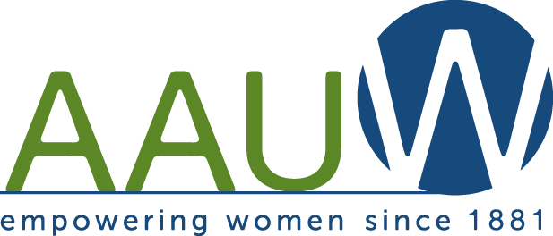
Northern Ocean County Branch
(AAUW-NOCB)
Maureen O’Keefe Aptowicz Memorial $1,000 Scholarship Announcement
The American Association of University Women Northern Ocean County Branch (AAUW) will award a $1,000 scholarship in memory of one of our members, Maureen O’Keefe Aptowicz.
Qualifications:
- High school senior, class of 2025
- Resident of Ocean or Monmouth County, NJ
- Enrolled full time in college in the school year 2025 - 2026
- Major in STEM (Science, Technology, Engineering, Mathematics) related program
- Embrace the mission of AAUW: The American Association of University Women (AAUW) advances equity for women and girls through advocacy, philanthropy, and research.

Interested women may complete the requirements and mail them to:

AAUW-NOCB
207 Chatham Lane
Pt. Pleasant, NJ 08742

Applications must be completed and returned by May 1, 2025.

If you have any questions, please contact us at AAUWNOCBNJ@gmail.com.
Please include in the subject area “Maureen O’Keefe Aptowicz Scholarship”.

Northern Ocean County Branch
Maureen O’Keefe Aptowicz Memorial $1,000 Scholarship Application
Name: Phone number:
Address:

Email address:
Will you graduate from high school in June 2025?
Which high school? ____
Which college do you plan to attend in September 2025?

What STEM related field do you plan to pursue? _________________________________
Awards, Honors, and Scholarships

Community Service

Membership in Clubs and Organizations
Name of Club or Organization Office held, if any

Interests and Hobbies

Requirements:
- High School Transcript: Include or arrange to have an official copy of your high school transcript sent
to : AAUW-NOCB, 207 Chatham Lane Pt. Pleasant, NJ 08742.

- Letter of College Acceptance: Send a copy of your college acceptance.

- Application: Send completed AAUW Northern Ocean County Maureen O’Keefe Aptowicz Memorial Scholarship application.

- Essay: On a separate sheet, in not more than two double-spaced pages, discuss your educational and careers, goals, personal ambitions and how you embrace the mission of AAUW. Explain why you should be awarded this scholarship.

- Envelope size: Please mail in a #10 envelope (4 1/8 inches by 9 1/2 inches).

- Applications must be completed and returned to the address above by May 1, 2025.

- NOTE: Applicants may only apply for ONE AAUW-NOCB Scholarship.

Certification: I certify that this information is true, complete and accurate. I authorize release for the appropriate usage and public acknowledgement of the scholarship.

Applicant Signature: Date:

Parent/Guardian Signature: Date:

